Math 1 Name_________________________________

**2-3 Function Notation Practice 2** Date_______

**NOTE: *y* and *f*(*x*) are the same thing!**

1. If , find the following:

a. *f*(-2) b. *f*(7) c. *f*(-4)

2. If , find the following:

a. *h*(-3) b. *h*(5)

3. Let . If *f*(*x*) = 15, find *x*. 4. Let . If *h*(*x*) = 11, find *x*.

5. If 

a. Fill out the following table of values:

|  |  |  |  |  |  |  |
| --- | --- | --- | --- | --- | --- | --- |
| ***x*** | -2 | -1 | 0 | 1 | 2 | 3 |
| ***f*(*x*)** |  |  |  |  |  |  |

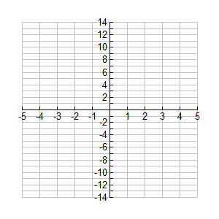b. Graph the function

6. If 

a. Fill out the following table of values:

|  |  |  |  |  |  |  |
| --- | --- | --- | --- | --- | --- | --- |
| ***x*** | -2 | -1 | 0 | 1 | 2 | 3 |
| ***f*(*x*)** |  |  |  |  |  |  |

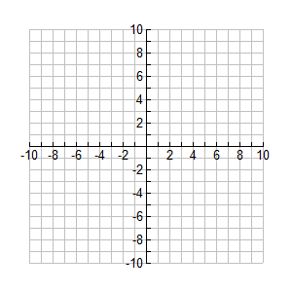b. Graph the function